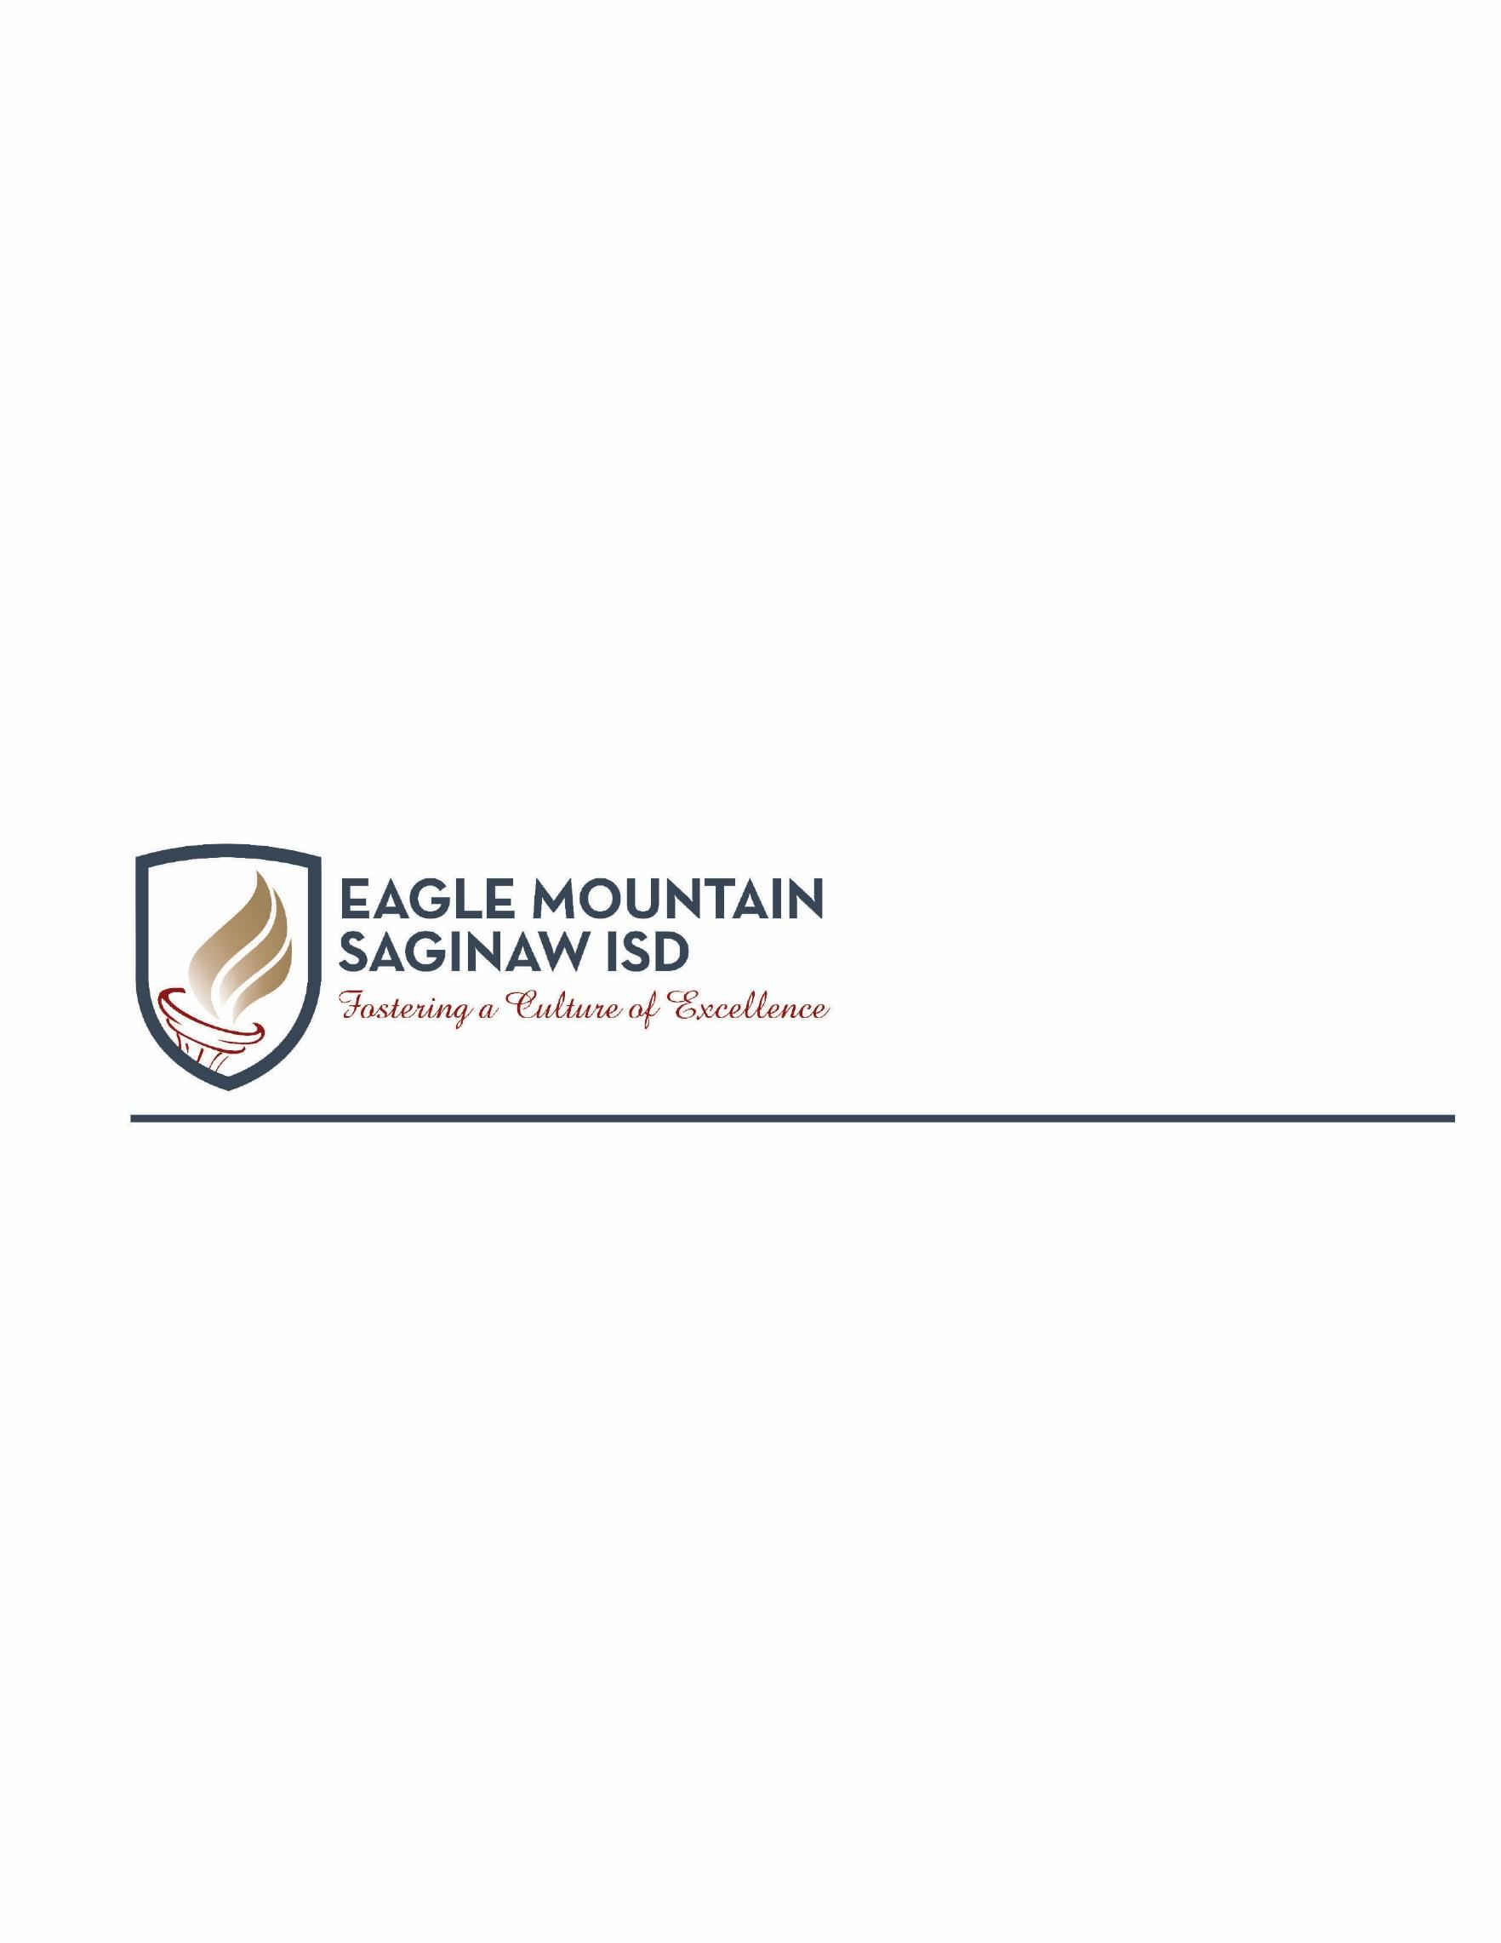

Dear Parent or Guardian,

The World History: Modern AP course content is structured around the investigation of six course themes and 19 key concepts in six different chronological periods, from approximately 8000 B.C.E. to the present. The AP World History: Modern course develops students’ capacity and ability to think and reason in a deeper, more systematic way, better preparing them for subsequent college courses. This course will use a college-level textbook and supplemental readings, documents, essays, and books on specific topics and themes.

The skills, course themes, periodization, and key concepts follow the AP curriculum framework:

THEME 1: HUMANS AND THE ENVIRONMENT

THEME 2: CULTURAL DEVELOPMENTS AND INTERACTIONS

THEME 3: GOVERNANCE

THEME 4: ECONOMIC SYSTEMS

THEME 5: SOCIAL INTERACTIONS AND ORGANIZATION

THEME 6: TECHNOLOGY AND INNOVATION

The themes and key concepts are intended to provide foundational knowledge for future college-level course work in history. Extra time is required on the part of AP students for class preparation, outside reading, and completion of assignments. AP courses provide students with a learning experience equivalent to that obtained in most college introductory courses. Students who take World History AP are expected to take the Advanced Placement Exam in the spring.

**6th 6 Weeks Overview**

During the majority of the sixth 6 weeks grading period, students will be engaged in course work over the following unit of study:

**Unit 10: Globalization, 1900 - Present (carried over from 5th six weeks)**

Rapid advances in science and technology altered the understanding of the universe and the natural world and led to advances in communication, transportation, industry, agriculture, and medicine. States responded in a variety of ways to the economic challenges of the 20th century. Rights-based discourses challenged old assumptions about race, class, gender, and religion. In much of the world, access to education as well as participation in new political and professional roles became more inclusive in terms of race, class, gender, and religion. Political and social changes of the 20th century led to changes in the arts and in the second half of the century, popular and consumer culture became more global. Arts, entertainment, and popular culture increasingly reflected the influence of a globalized society. Consumer culture became globalized and transcended national borders.

**AP Exam Review Unit (Comprehensive)**

**The administration of the AP World History Exam will take place on May 16th**. The remainder of the year will be spent completing research based projects.

Throughout the sixth 6 weeks grading period, student knowledge and understanding will be assessed in a variety of ways, such as:

* Thinking Maps and Graphic Organizers
* Collaborative Small and Large Group Discussions (Paideia, Socratic)
* Document Analysis of Primary and Secondary Sources (Historiography)
* Analysis of Causation and Periodization
* Comparison and Contextualization
* Critical Listening and Note Taking/Summarizing
* Critical Questioning
* Historical Argumentation (as foundation toward DBQ & FRQ Writing Assignments)
* Synthesis and Historical Interpretation (Revisionist History)
* Mental Mapping – geographical awareness
* Formative and Summative Assessments
* Thesis Development
* Short Answer Questions
* Skeleton Essays
* AP Essays

Please feel free to contact us if you have any questions or concerns regarding your student. We look forward to working with you and your child to ensure academic success.

Respectfully,

AP World History Teachers